Mrs. Case is the Executive Director of Crisis House, a landmark social service agency established in 1970 in El Cajon, California. For 30 years prior she served as the Vice President of Programs of Father Joe’s Villages in San Diego, California. Under her leadership, St. Vincent de Paul Village (a partner agency of Fr. Joe’s Villages), grew from a 100-bed shelter to a 900-bed rehabilitation center for the homeless meeting the needs of families, children, teens on their own and single men and women, veterans, HIV/AIDS, seniors and other homeless people with special needs to begin the process of regaining their self-sufficiency. Services were complex, integrated and multi-sited with the hub located on a 3-block campus in the East Village section of San Diego. Also located on the campus and part of her oversight were five permanent supportive housing projects totaling over 400 units. The Center is the largest of its kind in the region and has received many awards. Mary replicated the model in Las Vegas, Nevada (MASH Village) and Indio, California (Martha’s Village & Kitchen) and consulted with service providers around the country to replicate the model in their communities. Haven for Hope in San Antonia, Texas is most notable.
Mary Case, M.S.W.
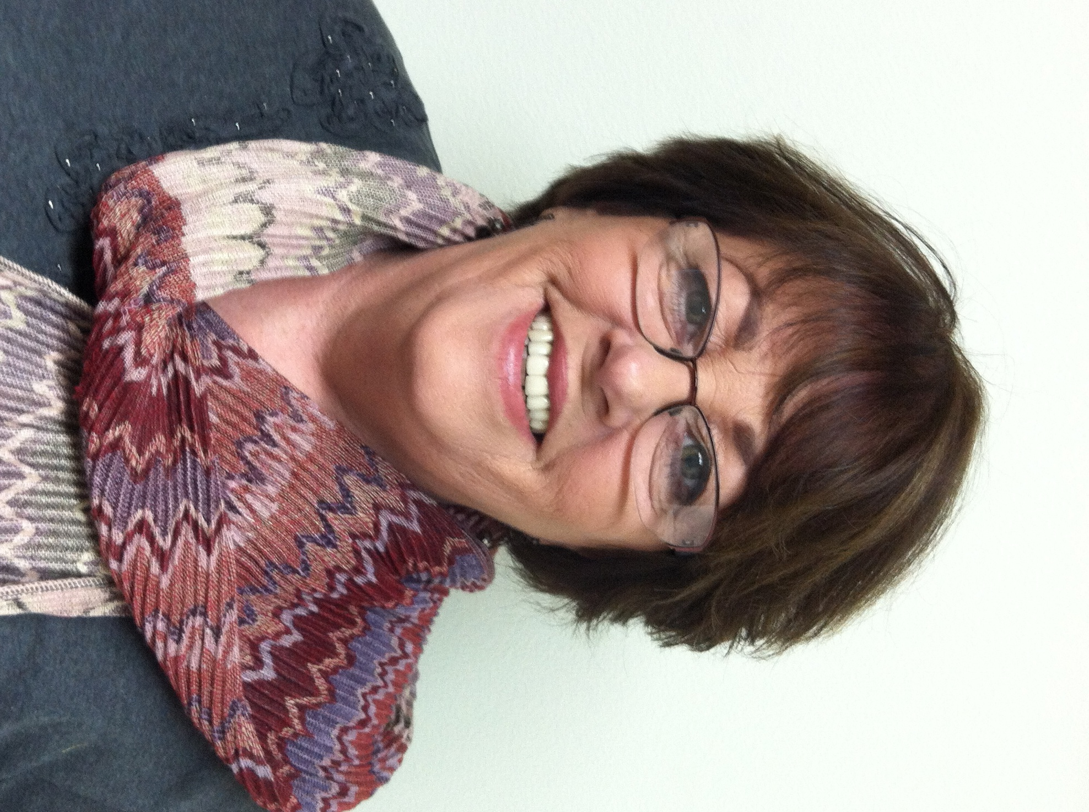
Pursuing innovative solutions to support community needs is Mary’s passion. She increased the capacity of St. Vincent de Paul Village to grow in services and resources adding $1 million in new grant revenue in one year by spearheading a movement from reporting outputs (numbers served) to measuring outcomes (impact of services). She developed the Village Training Institute to increase the capacity of 300 grassroots organizations throughout the western United States and granted sub-awards to over 30 agencies. Informed by national best practices, Mary enhanced the Village’s continuum of services to include many innovations such as:

- Homeless Prevention & Shelter Diversion
- Rapid Re-housing
- Project 25 and Housing First Strategies with Veterans
- The first Assertive Community Treatment (ACT) Team for special needs tenants
- Developed a Token Economy for teens
- Created Bridges to Independence, a client-centered incentive to self-sufficiency
- Tripled the size of the Village Family Health Center
- Acquired Federally Qualified Health Center status
- Added a mobile health clinic
- Created a medical home for the Serial Inebriate Program (SIP) and Project 25
- Acquired the only LIHP county contract let in 2011

Ms. Case is active in the community serving as founding member of the Mayor’s Task Force on the Homeless and past President of the Regional Task Force on the Homeless (2010-2013). Mary served on the Emergency Food and Shelter Board and was elected to serve three terms as the Social Issues Chair of the Centre City Advisory Committee (CCAC) to the City Council on downtown redevelopment before resigning in 2011. Mary currently serves on the Regional Continuum of Care Council (RCCC); Steering and other committees and the SDSU School of Social Work Advisory Board. Mary is respected by her colleagues and recognized for her collaborative style, integrity and passion to make a difference to be part of the solution.
Other community efforts that Mary has brought to fruition include: the first ever Homeless Forum Series culminating in a Summit on Homelessness; the Mayor’s Holiday Shelter in Golden Hall and Inclement and Seasonal Winter Shelters in San Diego, La Mesa and El Cajon.
During her tenure of service, Mary has been awarded various recognitions. More recent of note are; Recognition for Outstanding Community Service as host of Project Homeless Connect East County from Senator Joel Anderson, Assemblyman Brian Jones and Mayor of El Cajon Bill Wells 2015; “Women Who Mean Business Award” 2014, San Diego Business Journal; “Woman in Non-Profit Leadership” Finalist, East County Chamber of Commerce 2014.

