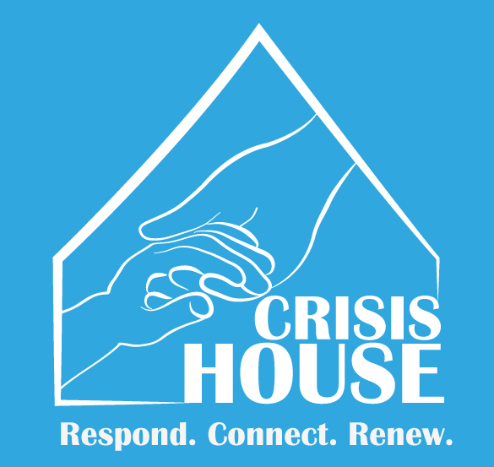BABY DRIVE

Support Crisis House

All baby items to assist very low income families for their newborn babies.

Items needed….

* 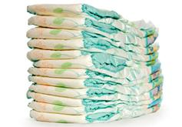Diapers (All Sizes) - Formula
* 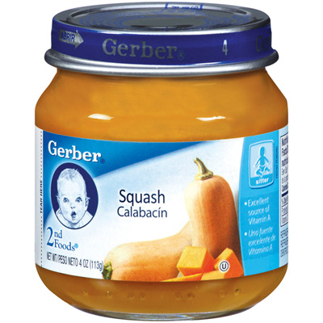Baby Food - Baby Cereal
* Baby Wipes - Diaper Bags
* 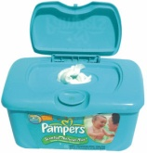Diaper Rash Creams - Blankets
* [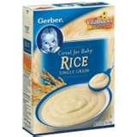](http://images.search.yahoo.com/images/view;_ylt=A2KJkew8gi1QH0EA5lKJzbkF;_ylu=X3oDMTBlMTQ4cGxyBHNlYwNzcgRzbGsDaW1n?back=http://images.search.yahoo.com/search/images?_adv_prop=image&va=baby+rice+cereal&fr=yfp-t-543-1-s&tab=organic&ri=2&w=200&h=200&imgurl=www.buythecase.net/uploads/products/200/1500000714.jpg&rurl=http://www.buythecase.net/product/4865/gerber_single_grain_rice_cereal_for_baby/&size=72.4+KB&name=Buy+The+Case:+Gerber+Single+Grain+Rice+Cereal+For+Baby&p=baby+rice+cereal&oid=610296373f8af2e6bcadd368c0b59e5e&fr2=&fr=yfp-t-543-1-s&tt=Buy+The+Case:+Gerber+Single+Grain+Rice+Cereal+For+Baby&b=0&ni=28&no=2&ts=&tab=organic&sigr=12g1gmi3q&sigb=13ie2d1k5&sigi=11mfu6erj&.crumb=91fxLLvpWRc)Bottles, Bibs & Burp Cloths
* Bath and Hygiene Items
* Gift Cards for specialty items.

Crisis House is a 501 (c)(3) non-profit charitable organization. Our Federal Tax ID # is 33-0217339. Donations are tax deductible.